Data Science using R Laboratory
(PMC 401)
List of Programs
Sl No. | Problem Statement | Date of Execution
1. | Apply basic R programming concepts to develop a program that creates a numeric vector of marks for 10 students, uses conditional statements to classify each student as Distinction, First Division, Second Division, Pass, or Fail, and displays the results using a loop. Further, install and load the ggplot2 package and generate a bar chart to visualize the students’ marks.
2. | Apply appropriate R functions to compute the mean, mode, variance, and standard deviation of variables in the mtcars dataset and display the results.
3. | Load a dataset from a CSV file in R and generate a bar chart, pie chart, and 3D pie chart to visualize the data.
4. | Analyze a given CSV dataset to identify missing and inconsistent values and perform data cleaning using suitable R functions.
5. | Plot the given CSV dataset in both 2D and 3D formats using appropriate R plotting functions and label the axes clearly.
6. | Perform a linear regression on the following mice dataset:  Height: 140, 142, 150, 147, 139, 152, 154, 135, 148, 147  Weight: 59, 61, 66, 62, 57, 68, 69, 58, 63, 62  Derive the relationship coefficients and summarize the regression results.
7. | Apply logistic regression to the Iris dataset, creating a subset with only two species, and interpret the results.
8. | Implement and apply the KNN classification algorithm on a large dataset using R.
9. | Implement the ID3 algorithm to build a decision tree model using R.
10. | Apply the K-means clustering algorithm to the given dataset and interpret the resulting clusters.
11. | Implement the CURE (Clustering Using Representatives) algorithm in R to perform clustering on a given dataset. Instead of using built-in functions, manually apply the CURE operations to partition the data into clusters.
12. | Implement suitable anomaly detection techniques in R for the given dataset and evaluate the detected outliers.
13. | Implement the Apriori algorithm in R to discover frequent itemsets and generate association rules from the given dataset.

Problem Statement 1: Apply basic R programming concepts to develop a program that creates a numeric vector of marks for 10 students, uses conditional statements to classify each student as Distinction, First Division, Second Division, Pass, or Fail, and displays the results using a loop. Further, install and load the ggplot2 package and generate a bar chart to visualize the students’ marks.
Objective: The objective of this program is to apply basic R programming concepts to create and manipulate a numeric vector of student marks. It uses conditional statements and looping constructs to classify students based on their performance and displays the results. Additionally, the program visualizes the marks of students using a bar chart with the ggplot2 package.

R Program:
# Step 1: Create a numeric vector of marks for 10 students
# A numeric vector in R is a one-dimensional collection of numbers stored in a single variable
marks <- c(85, 72, 64, 58, 91, 47, 39, 76, 69, 82)

# Step 2: Create a vector of student names
#paste() is used to combine (join) text, numbers, or variables into a single character string.
students <- paste("Student", 1:10)

# Step 3: Display student results using a loop and conditional statements

for (i in 1:length(marks)) {

# Check for Distinction
if (marks[i] >= 75) {
result <- "Distinction"

# Check for First Division
} else if (marks[i] >= 60) {
result <- "First Division"

# Check for Second Division
} else if (marks[i] >= 50) {
result <- "Second Division"

# Check for Pass
} else if (marks[i] >= 40) {
result <- "Pass"

# Otherwise, Fail
} else {
result <- "Fail"
}
# Print the student name, marks, and result
cat(students[i], "- Marks:", marks[i], "- Result:", result, "\n")
}

# Step 4: Install ggplot2 package (run only once)
install.packages("ggplot2")

# Step 5: Load the ggplot2 library
library(ggplot2)

# Step 6: Create a data frame for plotting
student_data <- data.frame(
Student = students,
Marks = marks
)

# Step 7: Generate a bar chart using ggplot2
#geom_bar()
# Used to draw bar charts in ggplot2.
# stat = "identity"
#Tells ggplot to use the actual values from the data.
#(Not counting rows; height of bars = given y-values)
# fill = "steelblue"
#Sets the color of the bars to steel blue.

ggplot(student_data, aes(x = Student, y = Marks)) +
geom_bar(stat = "identity", fill = "steelblue") +
labs(
title = "Marks of Students",
x = "Students",
y = "Marks"
) +
theme_minimal()

OUTPUT
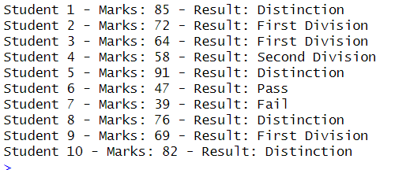
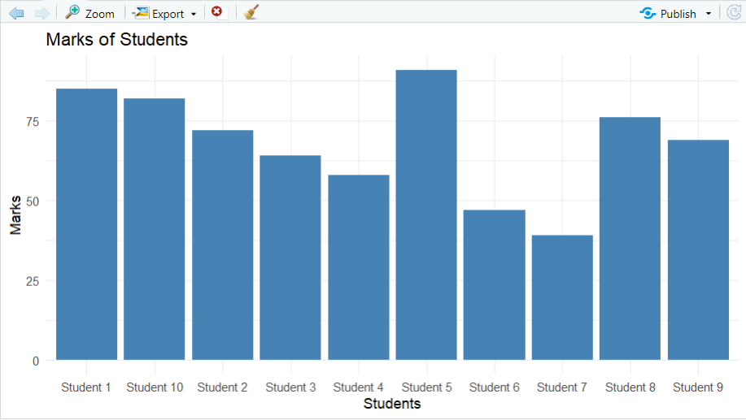
**Note**
What is aes() in ggplot2?
aes() stands for Aesthetics.It is used to tell ggplot how your data should be mapped to the chart.
ggplot(student_data, aes(x = Student, y = Marks))
- Creates a ggplot object
- Uses the dataset student_data
- Maps:
  - Student → x-axis
  - Marks → y-axis
geom_bar(stat = "identity", fill = "steelblue")
- Draws a bar chart
- stat = "identity" means:
  - Use the actual values of Marks
  - (Not counting or summarizing data)
- fill = "steelblue":
  - Colors the bars steel blue
labs(
Adds labels to the chart:
title = "Marks of Students"
- Sets the main title of the chart
x = "Students"
- Labels the x-axis
y = "Marks"
- Labels the y-axis
for
→ Starts a loop (repeats an action)
i
→ A loop variable
→ It takes values one by one
1:length(marks)
→ Creates a sequence from 1 to the total number of elements in marks
- If marks has 5 values → 1:5

Problem Statement 2: Apply appropriate R functions to compute the mean, mode, variance, and standard deviation of variables in the mtcars dataset and display the results.

Objective: The objective of this program is to apply built-in R functions to compute descriptive statistics such as mean, mode, variance, and standard deviation for selected variables in the mtcars dataset and display the results in a readable format.

R Program:
# Step 1: Load the built-in mtcars dataset
# mtcars is a built-in dataset in R.
data(mtcars)

# Step 2: Display the first few rows of the dataset
head(mtcars)
# head() function is used to view the first few rows of a dataset (default = 6).

# Step 3: Select a numeric variable (Miles Per Gallon)
#the $ operator is used to access a specific column (variable) from a data frame or list.
mpg_data <- mtcars$mpg

# Step 4: Calculate the mean of the variable
mean_mpg <- mean(mpg_data)

# Step 5: Calculate the variance of the variable
# Variance in mtcars measures how much a car variable (like mpg or hp) differs from its #average value across all cars.

variance_mpg <- var(mpg_data)
# Step 6: Calculate the standard deviation of the variable
sd_mpg <- sd(mpg_data)

# Step 7: Define a custom function to calculate the mode
get_mode <- function(x) {
unique_values <- unique(x) # Find unique values
unique_values[which.max(tabulate(match(x, unique_values)))]
}

# Step 8: Calculate the mode of the variable
mode_mpg <- get_mode(mpg_data)

# Step 9: Display all the calculated results
cat("Mean of mpg:", mean_mpg, "\n")
cat("Mode of mpg:", mode_mpg, "\n")
cat("Variance of mpg:", variance_mpg, "\n")
cat("Standard Deviation of mpg:", sd_mpg, "\n")

OUTPUT
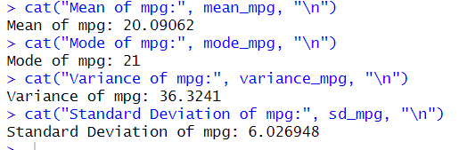
NOTE
get_mode <- function(x)
- Creates a function named get_mode
- x is the input vector (example: marks, mpg data, etc.)

2. unique_values <- unique(x)
- unique(x) finds all different (distinct) values in x
- Stores them in unique_values
Example:
If x = c(2, 3, 2, 5, 3, 2)
→ unique_values = c(2, 3, 5)

3. match(x, unique_values)
- Tells which unique value each element of x matches
Example:
x = c(2, 3, 2, 5, 3, 2)
unique_values = c(2, 3, 5)
Example : 1 2 1 3 2 1

4. tabulate(...)
- Counts how many times each number appears
From above:
1 → 3 times
2 → 2 times
3 → 1 time

5. which.max(...)
- Finds the position of the highest frequency
- Here → position 1 (because value at position 1 appears most)

6. unique_values[which.max(...)]
- Picks the value from unique_values
- That value is the mode
Mode = 2

Problem Statement 3: Load a dataset from a CSV file in R and generate a bar chart, pie chart, and 3D pie chart to visualize the data.

Objective: The objective of this program is to load data from a CSV file into R and visualize the data using different graphical techniques such as bar chart, pie chart, and 3D pie chart for better understanding and comparison.

R Program:
# Step 1: Set the working directory (change path as per your system)
# This is the folder where the CSV file is stored
setwd("C:/Users/viplaw/Documents")

# Step 2: Load the dataset from a CSV file
# Assume the CSV file name is "sales.csv"
data <- read.csv("sales.csv")

# Step 3: Display the dataset
print(data)

# Step 4: Extract values and labels from the dataset
# Assume first column contains categories and second column contains values
categories <- data[, 1]
values <- data[, 2]

# Step 5: Create a bar chart
barplot(
values,
names.arg = categories,
col = "skyblue",
main = "Bar Chart Representation",
xlab = "Categories",
ylab = "Values"
)

# Step 6: Create a pie chart
pie(
values,
labels = categories,
col = rainbow(length(values)),
main = "Pie Chart Representation"
)

# Step 7: Install plotrix package for 3D pie chart (run only once)
install.packages("plotrix")

# Step 8: Load the plotrix library
library(plotrix)

# Step 9: Create a 3D pie chart
pie3D(
values,
labels = categories,
explode = 0.1,
main = "3D Pie Chart Representation"
)

Sample CSV File Format (sales.csv)
Product, Sales
A, 120
B, 200
C, 150
D, 80

OUTPUT

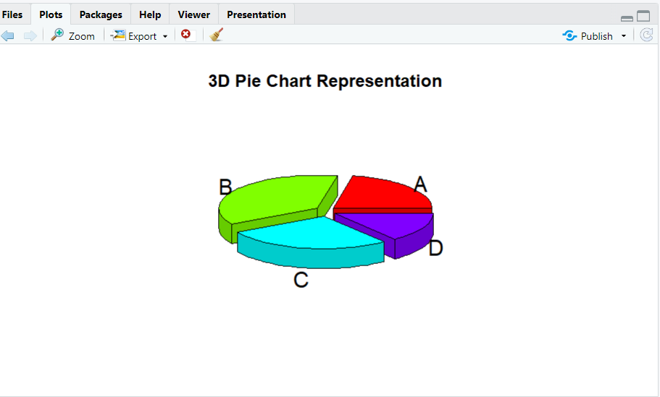

NOTE:
Step 1: Set the Working Directory
setwd("C:/Users/vipla/Documents")
This command tells R where to look for files.
The folder C:/Users/vipla/Documents is set as the current working directory, so R will search for sales.csv in this location.
🔹 Step 2: Load the CSV Dataset
data <- read.csv("sales.csv")
- read.csv() reads the CSV file.
- The data is stored in a data frame called data.
🔹 Step 3: Display the Dataset
print(data)
This prints the dataset in the console so you can verify that the data has been loaded correctly.
Example output:
Product Sales
1 A 120
2 B 200
3 C 150
4 D 80

🔹 Step 4: Extract Categories and Values
categories <- data[, 1]
values <- data[, 2]
- data[,1] extracts the first column (Product names).
- data[,2] extracts the second column (Sales values).
- These are stored separately for plotting.

🔹 Step 5: Create a Bar Chart
barplot(
values,
names.arg = categories,
col = "skyblue",
main = "Bar Chart Representation",
xlab = "Categories",
ylab = "Values"
)
This creates a bar chart:
- values → height of bars
- names.arg → labels on X-axis
- col → bar color
- main, xlab, ylab → chart title and axis labels
🔹 Step 6: Create a Pie Chart
pie(
values,
labels = categories,
col = rainbow(length(values)),
main = "Pie Chart Representation"
)
This creates a pie chart:
- Each slice represents a product’s sales
- rainbow() gives different colors to each slice

🔹 Step 7: Install the plotrix Package (One-Time)
install.packages("plotrix")
This installs the plotrix package, which is required for creating 3D pie charts.
This step is needed only once.
🔹 Step 8: Load the plotrix Library
library(plotrix)
This makes the functions of the plotrix package available for use.
🔹 Step 9: Create a 3D Pie Chart
pie3D(
values,
labels = categories,
explode = 0.1,
main = "3D Pie Chart Representation"
)
This creates a 3D pie chart:
- explode = 0.1 slightly separates the slices for better visualization
- Each slice represents the sales of a product

Problem Statement 4: Analyze a given CSV dataset to identify missing and inconsistent values and perform data cleaning using suitable R functions.

Objective: The objective of this program is to analyze a CSV dataset to identify missing and inconsistent values and perform data cleaning using appropriate R functions to improve data quality for further analysis.

R Program:
# Step 1: Set the working directory (modify as per your system)
setwd("C:/Users/viplaw/Documents")

# Step 2: Load the dataset from a CSV file
# Assume the file name is "employee.csv"
data <- read.csv("employee.csv", stringsAsFactors = FALSE)

# Step 3: Display the structure of the dataset
str(data)

# Step 4: Display summary statistics of the dataset
summary(data)

# Step 5: Identify missing values in the dataset
# Check how many missing values are present in each column
colSums(is.na(data))

# Step 6: View rows that contain missing values
data[!complete.cases(data), ]

# Step 7: Handle missing numeric values by replacing them with the column mean
data$Salary[is.na(data$Salary)] <- mean(data$Salary, na.rm = TRUE)

# Step 8: Handle missing character values by replacing them with "Unknown"
data$Department[data$Department == "" | is.na(data$Department)] <- "Unknown"

# Step 9: Identify inconsistent values
# Convert Age values less than or equal to 0 into NA
data$Age[data$Age <= 0] <- NA

# Step 10: Replace inconsistent Age values with the mean age
data$Age[is.na(data$Age)] <- mean(data$Age, na.rm = TRUE)

# Step 11: Remove duplicate rows from the dataset
data <- unique(data)

# Step 12: Display the cleaned dataset
print(data)

# Step 13: Display summary after data cleaning
summary(data)

Sample CSV File Format (employee.csv)
ID, Name, Age, Department, Salary
1, Ravi, 25, HR, 30000
2, Anita, , IT, 45000
3, John, -5, Finance,
4, Rahul, 30, , 40000
5, Ravi, 25, HR, 30000

OUTPUT
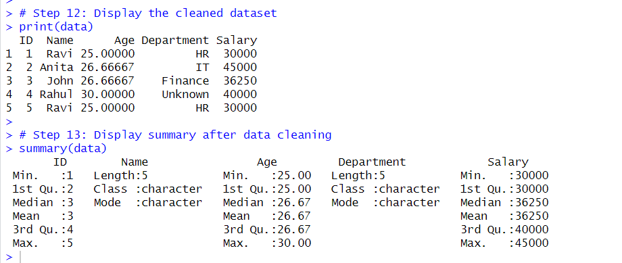

Problem Statement 5: Plot the given CSV dataset in both 2D and 3D formats using appropriate R plotting functions and label the axes clearly.

Objective: The objective of this program is to load a dataset from a CSV file and visualize the data using 2D and 3D plotting techniques in R, with clearly labeled axes for better understanding and interpretation.

R Program:
# Step 1: Set the working directory (modify as per your system)
setwd("D:/R_Lab")

# Step 2: Load the dataset from a CSV file
# Assume the file name is "data.csv"
data <- read.csv("data.csv")

# Step 3: Display the dataset
print(data)

# Step 4: Extract variables for plotting
# Assume the dataset has columns: X, Y, and Z
x <- data$X
y <- data$Y
z <- data$Z

# -------------------- 2D PLOT --------------------

# Step 5: Create a 2D scatter plot
plot(
x, y,
main = "2D Scatter Plot",
xlab = "X Axis Values",
ylab = "Y Axis Values",
col = "blue",
pch = 19
)

# -------------------- 3D PLOT --------------------

# Step 6: Install scatterplot3d package (run only once)
install.packages("scatterplot3d")

# Step 7: Load the scatterplot3d library
library(scatterplot3d)

# Step 8: Create a 3D scatter plot
scatterplot3d(
x, y, z,
main = "3D Scatter Plot",
xlab = "X Axis",
ylab = "Y Axis",
zlab = "Z Axis",
color = "red",
pch = 16
)

Sample CSV File Format (data.csv)
X, Y, Z
10, 20, 30
15, 25, 35
20, 30, 40
25, 35, 45
30, 40, 50

Output
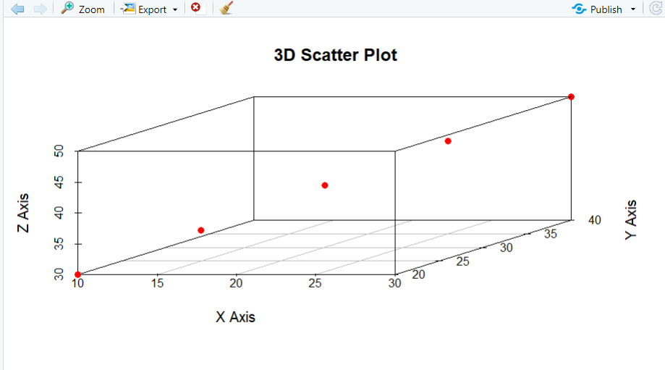

Problem Statement 6: Perform a linear regression on the following mice dataset:
Height: 140, 142, 150, 147, 139, 152, 154, 135, 148, 147
Weight: 59, 61, 66, 62, 57, 68, 69, 58, 63, 62
Derive the relationship coefficients and summarize the regression results.

Objective: The objective of this program is to perform linear regression on the given mice dataset to determine the relationship between height and weight, derive the regression coefficients, and summarize the regression results using appropriate R functions.

R Program:
# Step 1: Create a numeric vector for Height values
height <- c(140, 142, 150, 147, 139, 152, 154, 135, 148, 147)

# Step 2: Create a numeric vector for Weight values
weight <- c(59, 61, 66, 62, 57, 68, 69, 58, 63, 62)

# Step 3: Create a data frame using Height and Weight
mice_data <- data.frame(
Height = height,
Weight = weight
)

# Step 4: Display the dataset
print(mice_data)

# Step 5: Perform linear regression
# Weight is the dependent variable and Height is the independent variable
reg_model <- lm(Weight ~ Height, data = mice_data)

# Step 6: Display the regression coefficients
coefficients(reg_model)

# Step 7: Display the summary of the regression model
summary(reg_model)

Output
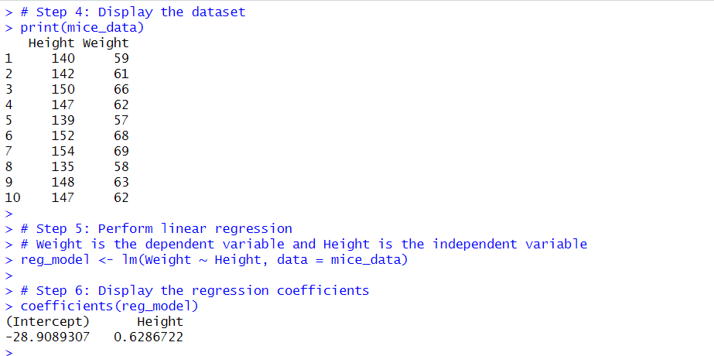
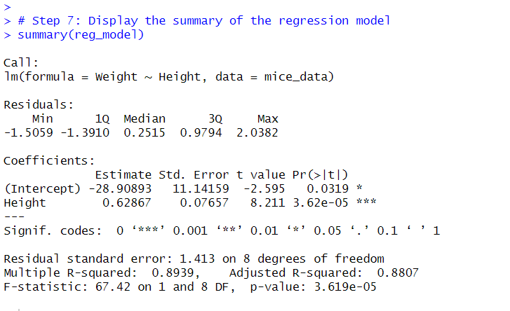

Problem Statement 7: Apply logistic regression to the Iris dataset, creating a subset with only two species, and interpret the results.

Objective: The objective of this program is to apply logistic regression on the Iris dataset by creating a subset containing only two species and to analyze and interpret the relationship between flower measurements and species classification.

R Program:
# Step 1: Load the built-in Iris dataset
data(iris)

# Step 2: Display the structure of the dataset
str(iris)

# Step 3: Create a subset with only two species
# Selecting Setosa and Versicolor
iris_subset <- subset(iris, Species != "virginica")

# Step 4: Convert Species into a factor (binary classification)
iris_subset$Species <- factor(iris_subset$Species)

# Step 5: Display first few rows of the subset
head(iris_subset)

# Step 6: Apply logistic regression
# Species is the dependent variable
# Sepal.Length and Sepal.Width are independent variables
logistic_model <- glm(
Species ~ Sepal.Length + Sepal.Width,
data = iris_subset,
family = binomial
)

# Step 7: Display the summary of the logistic regression model
summary(logistic_model)

# Step 8: Predict probabilities using the model
predicted_probabilities <- predict(logistic_model, type = "response")

# Step 9: Convert probabilities into predicted classes
predicted_class <- ifelse(predicted_probabilities > 0.5,
"versicolor", "setosa")

# Step 10: Create a confusion matrix
table(Predicted = predicted_class, Actual = iris_subset$Species)

Problem Statement 8: Implement and apply the KNN classification algorithm on a large dataset using R.

Objective: The objective of this program is to implement and apply the K-Nearest Neighbors (KNN) classification algorithm on a dataset using R, classify observations based on similarity, and evaluate the classification results.

R Program:
# Step 1: Load required library for KNN
# class package contains the knn() function
library(class)

# Step 2: Load the dataset
# Using iris dataset (can be replaced with any large CSV dataset)
data(iris)

# Step 3: Display dataset structure
str(iris)

# Step 4: Separate features and class labels
features <- iris[, 1:4] # Numeric predictor variables
class_labels <- iris$Species # Target class variable

# Step 5: Normalize the feature values
# Normalization improves KNN performance on large datasets
normalize <- function(x) {
return((x - min(x)) / (max(x) - min(x)))
}

features_normalized <- as.data.frame(lapply(features, normalize))

# Step 6: Split the dataset into training and testing sets
set.seed(123) # Ensures reproducibility
train_index <- sample(1:nrow(features_normalized), 0.7 * nrow(features_normalized))

train_data <- features_normalized[train_index, ]
test_data <- features_normalized[-train_index, ]

train_labels <- class_labels[train_index]
test_labels <- class_labels[-train_index]

# Step 7: Apply KNN classification
# k = 5 (number of nearest neighbors)
knn_predictions <- knn(
train = train_data,
test = test_data,
cl = train_labels,
k = 5
)

# Step 8: Display the predicted classes
print(knn_predictions)

# Step 9: Create a confusion matrix
confusion_matrix <- table(Predicted = knn_predictions, Actual = test_labels)
print(confusion_matrix)

# Step 10: Calculate classification accuracy
accuracy <- sum(diag(confusion_matrix)) / sum(confusion_matrix)
cat("Classification Accuracy:", accuracy * 100, "%\n")

Problem Statement 9: Implement the ID3 algorithm to build a decision tree model using R.

Objective: The objective of this program is to implement the ID3 algorithm to build a decision tree model on a dataset, classify observations, and analyze the tree structure and accuracy.

R Program:
# Step 1: Install and load the C50 package (run only once)
install.packages("C50")
library(C50)

# Step 2: Load a sample dataset
# Using iris dataset for demonstration (convert target to categorical)
data(iris)

# Step 3: Convert Species column to factor (categorical target)
iris$Species <- as.factor(iris$Species)

# Step 4: Display structure of dataset
str(iris)

# Step 5: Split the dataset into training and testing sets
set.seed(123) # Reproducibility
train_index <- sample(1:nrow(iris), 0.7 * nrow(iris))

train_data <- iris[train_index, ]
test_data <- iris[-train_index, ]

# Step 6: Build a decision tree using C5.0 (ID3-like algorithm)
# Formula: Species ~ all other variables
tree_model <- C5.0(Species ~ ., data = train_data)

# Step 7: Display the tree summary
summary(tree_model)

# Step 8: Make predictions on the test set
predictions <- predict(tree_model, test_data)

# Step 9: Create a confusion matrix
conf_matrix <- table(Predicted = predictions, Actual = test_data$Species)
print(conf_matrix)

# Step 10: Calculate accuracy
accuracy <- sum(diag(conf_matrix)) / sum(conf_matrix)
cat("Decision Tree Accuracy:", accuracy * 100, "%\n")

Problem Statement 10: Apply the K-means clustering algorithm to the given dataset and interpret the resulting clusters.

Objective: The objective of this program is to apply the K-Means clustering algorithm to a dataset, identify natural groupings of observations, and interpret the resulting clusters for meaningful patterns.

R Program
# Step 1: Load the dataset
# Example dataset: Iris numeric features
data(iris)

# Step 2: Select only numeric columns for clustering
# K-Means works on numeric data
iris_data <- iris[, 1:4]

# Step 3: Standardize the dataset (important for K-Means)
iris_scaled <- scale(iris_data)

# Step 4: Determine the number of clusters (k)
# Here, we choose k = 3 based on prior knowledge of species
k <- 3

# Step 5: Apply K-Means clustering
set.seed(123) # Reproducibility
kmeans_result <- kmeans(iris_scaled, centers = k, nstart = 25)

# Step 6: Display cluster centroids
print(kmeans_result$centers)

# Step 7: Display cluster assignment for each observation
print(kmeans_result$cluster)

# Step 8: Compare clusters with actual species (optional)
table(Cluster = kmeans_result$cluster, Species = iris$Species)

# Step 9: Visualize clusters using a 2D plot (first two principal components)
library(ggplot2)
iris_plot <- data.frame(iris_scaled, Cluster = factor(kmeans_result$cluster))
ggplot(iris_plot, aes(x = Sepal.Length, y = Sepal.Width, color = Cluster)) +
geom_point(size = 3) +
labs(title = "K-Means Clustering of Iris Data",
x = "Sepal Length",
y = "Sepal Width") +
theme_minimal()

Problem Statement 11: Implement the CURE (Clustering Using Representatives) algorithm in R to perform clustering on a given dataset. Instead of using built-in functions, manually apply the CURE operations to partition the data into clusters.

Objective: The objective of this program is to implement the CURE (Clustering Using Representatives) algorithm manually in R to perform clustering, identify representative points for each cluster, and partition a dataset into meaningful clusters.

R Program:
# Step 1: Load required library for distance calculations
library(stats)

# Step 2: Create a sample dataset
# Here we use a small 2D dataset for clarity
data_points <- data.frame(
x = c(1, 2, 3, 8, 9, 10, 20, 21, 22),
y = c(2, 1, 3, 8, 9, 7, 20, 21, 19)
)

# Step 3: Set number of clusters
k <- 3

# Step 4: Initialize each point as its own cluster
clusters <- lapply(1:nrow(data_points), function(i) data_points[i, , drop = FALSE])

# Step 5: Function to compute distance between two clusters
cluster_distance <- function(cluster1, cluster2) {
min(dist(rbind(cluster1, cluster2)))[1] # Use single linkage (min distance between clusters)
}

# Step 6: CURE parameters
num_representatives <- 2 # Number of representative points per cluster
shrink_factor <- 0.5 # Shrinking factor towards cluster centroid

# Step 7: Merge clusters until desired number (k) is reached
while(length(clusters) > k) {

# Step 7a: Find two closest clusters
min_dist <- Inf
merge_i <- merge_j <- 0
for(i in 1:(length(clusters)-1)) {
for(j in (i+1):length(clusters)) {
dist_ij <- cluster_distance(clusters[[i]], clusters[[j]])
if(dist_ij < min_dist) {
min_dist <- dist_ij
merge_i <- i
merge_j <- j
}
}
}

# Step 7b: Merge the two clusters
new_cluster <- rbind(clusters[[merge_i]], clusters[[merge_j]])

# Step 7c: Compute centroid of new cluster
centroid <- colMeans(new_cluster)

# Step 7d: Select representative points (farthest from centroid)
distances_to_centroid <- apply(new_cluster, 1, function(row) sqrt(sum((row - centroid)^2)))
rep_indices <- order(distances_to_centroid, decreasing = TRUE)[1:num_representatives]
representatives <- new_cluster[rep_indices, ]

# Step 7e: Shrink representatives towards centroid
representatives <- centroid + shrink_factor * (representatives - centroid)

# Step 7f: Replace merged clusters with new cluster (with representatives)
clusters <- clusters[-c(merge_i, merge_j)]
clusters[[length(clusters)+1]] <- representatives
}

# Step 8: Display final clusters and their representatives
for(i in 1:length(clusters)) {
cat("Cluster", i, "representatives:\n")
print(clusters[[i]])
cat("\n")
}

# Step 9: Plot the clusters
plot(data_points$x, data_points$y, col = "gray", pch = 16, main = "CURE Clustering")
colors <- c("red", "blue", "green")
for(i in 1:length(clusters)) {
points(clusters[[i]][,1], clusters[[i]][,2], col = colors[i], pch = 19, cex = 2)
}
legend("topleft", legend = paste("Cluster", 1:k), col = colors, pch = 19)

Problem Statement 12: Implement suitable anomaly detection techniques in R for the given dataset and evaluate the detected outliers.

Objective: The objective of this program is to apply suitable anomaly detection techniques to identify outliers in a dataset and evaluate them using statistical and visualization methods.

R Program:
# Step 1: Load required library for advanced outlier detection
install.packages("DMwR") # Contains LOF function (run only once)
library(DMwR)

# Step 2: Load dataset
# Example dataset
data <- data.frame(
ID = 1:10,
Score = c(50, 52, 48, 55, 53, 500, 51, 49, 54, 47)
)

# Step 3: Display dataset
print(data)

# ---------------- Statistical Method: Z-Score ----------------

# Step 4: Compute Z-scores for the numeric variable 'Score'
z_scores <- scale(data$Score)

# Step 5: Identify outliers with |Z| > 3
outliers_z <- which(abs(z_scores) > 3)
cat("Outliers detected using Z-score:", data$ID[outliers_z], "\n")

# ---------------- Statistical Method: IQR ----------------

# Step 6: Compute Q1, Q3, and IQR
Q1 <- quantile(data$Score, 0.25)
Q3 <- quantile(data$Score, 0.75)
IQR <- Q3 - Q1

# Step 7: Identify outliers outside 1.5*IQR
outliers_iqr <- which(data$Score < (Q1 - 1.5*IQR) | data$Score > (Q3 + 1.5*IQR))
cat("Outliers detected using IQR:", data$ID[outliers_iqr], "\n")

# ---------------- Distance-Based Method: Mahalanobis Distance ----------------

# Step 8: Compute Mahalanobis distance (for multivariate data)
# Here Score is univariate; extendable to multiple columns
center <- colMeans(data[ , "Score", drop=FALSE])
cov_matrix <- cov(data[ , "Score", drop=FALSE])
mahal_dist <- mahalanobis(data[ , "Score", drop=FALSE], center, cov_matrix)

# Step 9: Identify outliers using chi-square threshold (p < 0.01)
threshold <- qchisq(0.99, df = 1)
outliers_mahal <- which(mahal_dist > threshold)
cat("Outliers detected using Mahalanobis distance:", data$ID[outliers_mahal], "\n")

# ---------------- Visualization ----------------

# Step 10: Boxplot to visualize outliers
boxplot(data$Score, main="Boxplot for Outlier Detection", col="lightblue", horizontal=TRUE)

# Step 11: Scatter plot with outliers highlighted
plot(data$ID, data$Score, pch=19, col="blue", main="Outlier Detection")
points(data$ID[outliers_z], data$Score[outliers_z], col="red", pch=19, cex=1.5)
legend("topleft", legend=c("Normal", "Outlier (Z-score)"), col=c("blue","red"), pch=19)

Problem Statement 13: Implement the Apriori algorithm in R to discover frequent itemsets and generate association rules from the given dataset.

Objective: The objective of this program is to apply the Apriori algorithm to discover frequent itemsets and generate association rules from transactional data using R.

R Program:
# Step 1: Install and load the arules package (run once)
install.packages("arules")
library(arules)

# Step 2: Create a sample transactional dataset
# Each row represents a transaction with purchased items
transactions_list <- list(
c("Milk", "Bread", "Butter"),
c("Milk", "Bread"),
c("Milk", "Diaper", "Beer", "Eggs"),
c("Bread", "Butter", "Diaper"),
c("Milk", "Bread", "Diaper", "Butter"),
c("Bread", "Butter"),
c("Milk", "Bread", "Butter", "Diaper")
)

# Step 3: Convert the list to "transactions" class
trans <- as(transactions_list, "transactions")

# Step 4: Inspect the transactions
inspect(trans)

# ---------------- Apriori Algorithm ----------------

# Step 5: Apply Apriori to find frequent itemsets
# Set minimum support = 0.4 (40% of transactions)
frequent_itemsets <- apriori(trans, parameter = list(supp = 0.4, target = "frequent itemsets"))

# Step 6: Inspect the frequent itemsets
inspect(frequent_itemsets)

# Step 7: Generate association rules
# Set minimum confidence = 0.7 (70%)
rules <- apriori(trans, parameter = list(supp = 0.4, conf = 0.7, target = "rules"))

# Step 8: Inspect the rules
inspect(rules)

# Step 9: Sort rules by lift (measure of interestingness)
rules_sorted <- sort(rules, by="lift", decreasing = TRUE)
inspect(rules_sorted)

# Step 10: Plot the rules (optional)
install.packages("arulesViz") # Run once
library(arulesViz)
plot(rules_sorted, method="graph", engine="htmlwidget")

